Another world is needed. Together it is possible!
by Andrew Conradi, ofs

On agroecology: fourth in a series on the 2016 World Social Forum

In the last article on climate I mentioned that climate change and agroecology bring together so many related subjects which Pope Francis wrote about in Laudato Si’ (49 & 138).

Some of these interconnections include: hunger, small farmers who feed most of the world, land ownership or use, land grabbing and dispossession, credit, seeds, patenting, genetically modified organisms (GMO’s), corporate control of agri-business, food security & sovereignty, mining, chemical pollution, subsidies, taxation etc.

One of the umbrella organisations in the forefront of the struggle for sustainable agriculture is La Via Campesina and one of its members of landless peasants (MST) is strongly supported by the Brasilian bishops. La Via Campesina brings together over 200 million members through 164 organizations in 73 countries. Over the past 20 years, La Via Campesina has become one of the world’s biggest social movements. The National Farmers Union (NFU) of Canada is a member. NFU former Presidents Wayne Easter and Nettie Wiebe played key roles in the founding and development of La Via Campesina.

Agroecology is suggested as a solution. Here is one definition: “The science of agroecology—the application of ecological concepts and principles to the design and management of sustainable agricultural ecosystems—provides a framework to assess the complexity of agroecosystems. This approach is based on enhancing the habitat both aboveground and in the soil to produce strong and healthy plants by promoting beneficial organisms while adversely affecting crop pests (weeds, insects, diseases, and nematodes).”

As La Via Campesina explained in 2015: “Agroecology is the answer to how to transform and repair our material reality in a food system and rural world that has been devastated by industrial food production and its so-called Green and Blue Revolutions. We see agroecology as a key form of resistance to an economic system that puts profit before life.”

“The corporate model over-produces food that poisons us, destroys soil fertility, is responsible for the deforestation of rural areas, the contamination of water and the acidification of oceans and killing of fisheries. Essential natural resources have been commodified, and rising production costs are driving us off the land. Farmers’ seeds are being stolen and sold back to us at exorbitant prices, bred as [patented GMO] varieties that depend on costly, contaminating agrochemicals.”

“The industrial food system is a key driver of the multiple crises of climate, food, environmental, public health and others. Free trade and corporate investment agreements, investor-state dispute settlement agreements, and false solutions such as carbon markets, and the growing financialization of land and food, etc., all further aggravate these crises. Agroecology within a food sovereignty framework offers us a collective path forward from these crises.” (La Via Campesina, 2015)

La Vía Campesina introduced the idea of food sovereignty at the World Food Summit in 1996 as "the right of peoples to healthy and culturally appropriate food produced through sustainable methods and their right to define their own food and agriculture systems."

Hélène Boyko-Tremblay, a member of Development and Peace-Caritas Canada and an organic farmer in Saskatchewan, presented on how she discovered agroecology through her involvement in Development and Peace’s campaign Sow Much Love (2014). She spoke of how agroecology is still a little known practice in Canada, and explained that in Canada, there needs to be a huge shift in mindset in how we farm. She said agroecology gives hope for the future. Caritas Canada conducted campaigns for small farmers in 2011, 2014 and again this year coupled with agroecology.
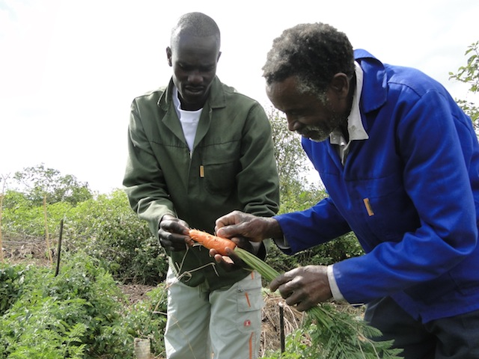
Agroecology can also contribute significantly to achieving targets for reducing greenhouse gas emissions and limiting the impacts of climate change. Carbon sequestration is the process through which agricultural and forestry practices remove carbon dioxide (CO2) from the atmosphere.
La Via Campesina: Topara Demo field: a successful example of agroecology in Zimbabwe

In 2011 the UN Human Rights Council wrote: “Agroecological farming can double food production within 10 years, while mitigating climate change and alleviating poverty.”
Governments must shift subsidies and research funding from agro-industrial monoculture to small farmers using ‘agroecological’ methods, according to the UN’s Special Rapporteur on the Right to Food (2014).

Fourth in a series of articles by Andrew Conradi, ofs on the 2016 World Social Forum. The first was a general introduction and touched on lifestyle and values, the second with mining, the third with climate change. The final articles will deal with suggestions on what we can do to help bring about the necessary changes.

