A’s December 2022 Franciscan Voice Canada blog
by Andrew Conradi, ofs; JPIC & Laudato si' Animator

I acknowledge and thank the Lkwungen People
for allowing me to live, pray, work, and play on their lands. I am deeply sorry for the injustices inflicted upon the First Nations, Inuit and Métis peoples in Turtle Island by the complicity of Governments & settlers, including the Catholic Church, in the colonialism inherent in the Indian Act and Residential Schools including racism, neglect, many forms of abuse & cultural genocide. I commit to work for truth, healing and reconciliation.

1. CHANGES AT CARITAS INTERNATIONALIS
Following allegations of bullying and mistreatment of employees, Pope Francis on Tuesday (22 Nov 2022) in a decree, removed the entire leadership of the Roman Catholic Church's international charity & social justice wing and appointed a temporary Extraordinary Commissioner, Italian engineer and management consultant Dr Pier Francesco Pinelli, to run it. During his six-month mandate the Extraordinary Commissioner is entrusted with re-launching the organization.
The Pontiff's surprise decision was announced in a papal decree and involved the chiefs of Caritas Internationalis (CI), founded in 1951, a confederation with 162 members of Catholic relief, development and social services organisations working in over 200 countries with more than a million staff and volunteers, including Development & Peace/ Caritas Canada. The decision was published as members of Caritas International were in the middle of a two-day meeting in Rome for the first time since COVID-19. CI reported income of some 5.1 million euros ($5.2 million) in 2020 and expenditures of 4.4 million euros, according to the annual statement. Pope Francis is known to be unhappy with entities that spend a large proportion of their income on their own wages rather than actual projects.
Pinelli was appointed to oversee sweeping changes to the Vatican-based umbrella body in both its statutes (which were last revised only two years ago) and management.
Pinelli noting that in this process, and in the preparation for the General Assembly, former CI President Cardinal Luis Antonio Tagle will play a major role, and he will be particularly responsible for relations with local churches and national Caritas organisations. “Cardinal Tagle,” Pinelli said, “represents a point of reference for my work and his support is precious to ensure that all Caritas members participate in this journey.”

Other senior Caritas Internationalis figures losing their posts include Secretary General Aloysius John, Treasurer Alexander Bodmann, and Ecclesiastical Assistant Msgr. Pierre Cibambo.
Pinelli will also be helped by Maria Amparo Alonso Escobar, Caritas Internationalis’ Spanish head of advocacy, and Portuguese Jesuit Fr. Manuel Morujão, “for the personal and spiritual accompaniment of employees.” The papal decree said that Pinelli would work with the dicastery in his new role, which includes updating the organization’s statutes, ahead of a May 2023 general assembly.
Work to lay the foundations for the renewal process of the General Secretariat of Caritas Internationalis has commenced and will end with the General Assembly in May 2023 where Caritas Internationalis members are expected to elect a new leadership.
The purpose of this work is aimed at strengthening the Confederation's coordination instrument. This path includes the full participation of the regional secretariats and national Caritas agencies, which work daily in their territories to respond to humanitarian emergencies and to promote integral human development particularly for the poor and vulnerable.
Pinelli has experience in this sort of work having assisted Cardinal Blase Cupich with a 2021 review of the Vatican’s Dicastery for Promoting Integral Human Development, which paved the way for leadership changes in that organisation. The team also included Sister Helen Alford, vice-rector of the Pontifical Angelicum University, an ordinary member of the Pontifical Academy of Social Sciences.
In the 22 Nov press release, the human development dicastery stated that the removal of the organization’s leadership would have “no impact on the functioning of member organizations and the services of charity and solidarity they provide around the world; on the contrary, it will serve to strengthen such service.”
It explained that earlier this year it had commissioned a review of the “workplace environment” at Caritas Internationalis and “its alignment with Catholic values of human dignity and respect for each person.” [Pope Francis sends an inspection or appoints a commissioner whenever he wants to reform something.]
The statement noted that the Dicastery was given competence for Caritas Internationalis as part of Pope Francis’s reform of the Roman Curia, meaning the Vatican’s central governing bureaucracy, published earlier this year in his constitution, Predicate Evangelium.
Shortly after, the Dicastery said it commissioned a review of the “workplace environment” within the general secretariat of Caritas Internationalis, as well as “its alignment with Catholic values of human dignity and respect for each person.”
The review was carried out by a panel of independent experts including Pinelli, and psychologists Father Enrico Parolari and Doctor Francesca Busnelli, and both current and former employees were invited to participate.
The goal of the review, the statement said, was to improve Caritas Internationalis’s “management norms and procedures.” It found that despite management problems, “financial matters have been well-handled and fundraising goals regularly achieved.”
“No evidence emerged of financial mismanagement or sexual impropriety, but other important themes and areas for urgent attention emerged from the panel’s work,” the dicastery said. “Real deficiencies were noted in management and procedures, seriously prejudicing team spirit and staff morale.” Notwithstanding this regarding sexual impropriety, a CI report did mention sexual abuse in 2019 by a CI director in the Central African Republic https://www.caritas.org/2019/11/apology/. Apparently dealing with the offending cleric was left to his order’s superiors but there was a lack of follow up regarding this, which affected morale in CI.
Dicastery prefect Cardinal Michael Czerny commented: “In recent years we have seen the needs of the many whom Caritas serves increase markedly, and it is imperative that Caritas Internationalis be well prepared to meet these challenges.”
“Pope Francis invites us to consider ‘the mission that Caritas is called to carry out in the Church,” he said, saying “Charity is not a barren service nor a simple offering to be made in order to ease our conscience.”
“What we must never forget,” he said, “is that charity has its origin and its essence in God himself; charity is God our Father’s embrace of every person, particularly of the least and the suffering, those who occupy a preferential place in his heart.’”
[In this time of COP 27 may we repeat “Politics is the highest form of charity” (Pius XI, Paul VI, Francis; or it should be!]
In recent years, Caritas Internationalis has had a sometimes uneasy relationship with the Vatican which derived from the formulation of Benedict XVI’s encyclical Caritas in Veritate. In the encyclical, Benedict XVI stressed that human development and foreign aid could not be separated from the demand for truth. The encyclical also pointed to the fact that many international organizations were promoting abortion, contraception, sterilization, and euthanasia.
The Vatican reportedly blocked the re-election of Lesley-Anne Knight as Caritas Internationalis’ Secretary General in 2011. Knight’s non-confirmation also stemmed from the new approach given with the subsequent reform of Caritas Internationalis. However, her work was praised by the president of Caritas Internationalis at the time, Cardinal Oscar Andrés Rodriguez Maradiaga. Cardinal Robert Sarah, then head of the [now defunct] Pontifical Council “Cor Unum,” said at the time that the Vatican wanted the body to focus on its “Catholic identity.”
How this is to be done, by a church which “proposes, she imposes nothing” (Pope St John Paul II, 1990, Redemptor missio, 39) and works with all people of good will, remains to be seen. Tricky!
2. SYNODALITY FOOD FOR THOUGHT & QUESTIONS

US Bishops elect anti-Francis archbishop as new president & elect Coakley, a Viganò supporter, as No. 3 official
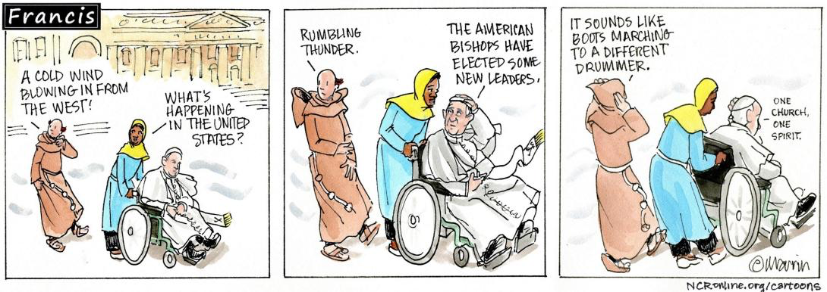

https://www.ncronline.org/feature-series/usccb-fall-assembly-2022/stories
How will this affect the North American Continental Synod Report to Rome? Will Canadian Bishops be able to stand up to US Bishops or will they be out-numbered & bull dozed? [196 U.S. vs 72 Canadian (arch)dioceses] What will the Mexican input reflect and where will they stand?
https://www.cccb.ca/wp-content/uploads/2022/11/NA-Continental-Stage-FAQ-en.pdf
What Episcopal Conferences will be participating in the North American Continental Phase?
• The Continental Stage for North America will be a collaboration between the Canadian Conference of Catholic Bishops (CCCB) and the United States Conference of Catholic Bishops (USCCB). While geographically part of North America, given their long history of partnership and ongoing work of the different Encuentros, Mexico will participate in the Continental Stage through the Latin American Episcopal Council (CELAM).
What will the North American Continental Stage consist of?
- The North American Continental Stage of the Synod has been planned in conjunction with representatives from the CCCB and USCCB. Ten (10) Virtual Assemblies reflecting on the Document for the Continental Stage will take place in late 2022 and early 2023, including five (5) in English, three (3) in Spanish, and two (2) in French. Virtual Assemblies will be followed by a debrief session with the North American writing team in early February 2023.
- The North American Writing team, made up of representatives from both the U.S. and Canadian Synod teams, will gather in early February 2023 for a writing retreat to draft a Continental Synthesis that will be submitted to the Secretariat for the Synod on March 31, 2023. Who will participate in the Virtual Continental Assemblies?
- 3-5 delegates will be appointed by Bishops in each of the 196 U.S. and 72 Canadian (arch)dioceses to represent their dioceses in the Virtual Continental Assemblies. Delegates will be placed into small groups prior to the assemblies to reflect the diversity of the Church in North America.
- What does the extension through October 2024 mean for the Synod?
- The extended timeline for the Synod will allow for more time for a deeper discernment by the members of the Synodal Assembly, as well as the People of God. The Universal Phase of the Synod will be held in two parts, the first in October 2023 and the second a year later in October 2024.
3. DID YOU KNOW THIS ABOUT SOCIAL JUSTICE?
I just learned that according to the Code of Canon Law, all of the Christian faithful, are “obliged to promote social justice and, mindful of the precept of the Lord, to assist the poor from their own resources” (Code of Canon Law 222 §2; Code of Canons of the Eastern Churches 25 §2). Pastors of parishes are obliged “to foster works through which the spirit of the Gospel is promoted, even in what pertains to social justice” (Code of Canon Law 528 §1). It is also “desirable that the Catholic faithful undertake any project in which they could cooperate with other Christians, not alone but together, such as works for charity and social justice” (Code of Canons of the Eastern Churches 908). (My emphasis added!)
4. CATHOLIC SOCIAL TEACHING IN UKRAINE This sums it up nicely!
Ukrainian Catholic Archbishop Borys Gudziak, of Philadelphia, USA, highlighted the Church’s social doctrine as an aspect of the Church’s distinctive message concerning the ongoing war in Ukraine.
In Ukraine, he said, people are rallying around four main principles of Catholic social doctrine: human dignity, solidarity, subsidiarity, and the common good:
“You can see that there's a fight for Ukrainian dignity. You can see the great solidarity. You hear that in the humanitarian efforts in the defence of the country. People are working at a grassroots level – subsidiarity means deciding things at the lowest level, which gives everybody a sense of authority and responsibility. And the struggle, the effort, the work, the project needs to be for the common good.”
And let us not forget these lines from St Nicolas The Wonderworker, Victoria, BC, Bulletin 10 April 2022: prayer for the afflicted people of ukraine in time of war
“Deliver Your vulnerable people from unjust aggressors, foreign invasion and the terror of war. Strengthen courageous defenders of the nation to fight virtuously, inspired more by love of those they protect than hatred of the enemy. O compassionate Lord, shelter the displaced, heal the wounded, console the orphan, protect the widow, comfort those who mourn, and mercifully receive into Your Kingdom those who have nobly died guarding their homeland against every aggression. Quickly make cease the spilling of blood of friend and foe alike, yet stir many to bravely struggle for that true justice which alone can bring lasting peace. O kind-hearted Lord, as You are our peace, soften the hearts of the unmerciful and convert those who promote hostilities toward reconciliation, so that Your beloved children of the land of Ukraine, may abide in that tranquility, justice and freedom which reflects your Kingdom, where You reign with Your eternal Father, and Your most holy, good and life-giving Spirit, now, and forever and ever. Amen.”

UKRAINE GENOCIDE
Ukraine accused the Kremlin on Saturday 26 Nov of using the same "genocidal" tactics that it used against it in the 1930s under Josef Stalin, on the 90th anniversary of the Soviet-era famine (the Holodomor “death by starvation”) that has taken on new resonance since the Russian invasion.
"On the 90th anniversary of the 1932-1933 Holodomor in Ukraine, Russia's genocidal war of aggression pursues the same goal as during the 1932-1933 genocide: the elimination of the Ukrainian nation and its statehood," Ukraine's foreign ministry said in a statement. President Volodymyr Zelenskyy said during a press briefing after the International Summit on Food Security in Kyiv on November 26, 2022, in a video posted on social media: “Once they wanted to destroy us with hunger, now – with darkness and cold. We cannot be broken.” We must pray for them!

Mother of God of Tenderness by Oleksandr Klymenko and Sofia Atlantova
Aleteia Courtesy of Marcin Mazur

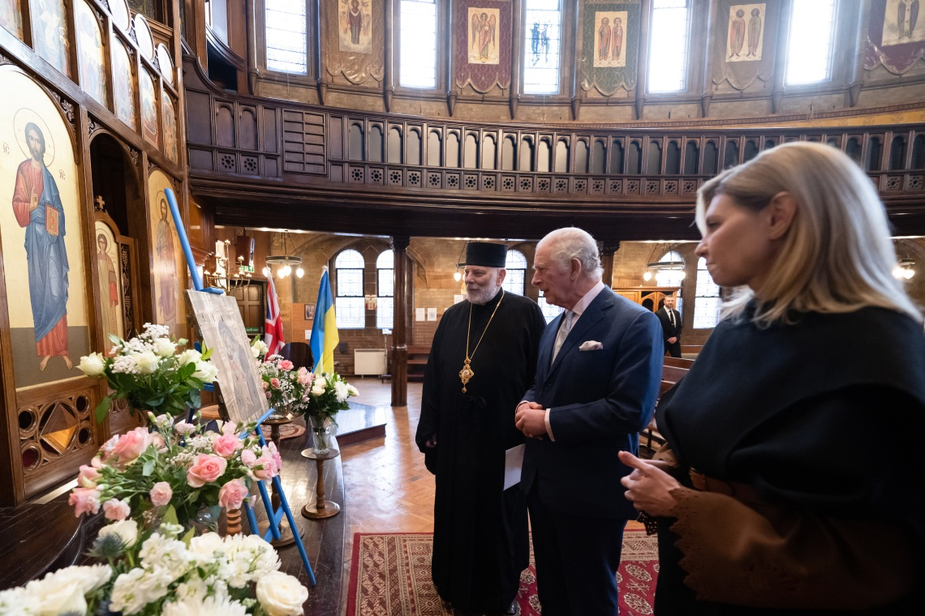
King Charles III of the United Kingdom and Canada recently received a special gift from Ukraine. While visiting the Ukrainian Catholic Cathedral in London, England the king was presented with an icon painted on a board from a wooden ammunition box.
During a ceremony in which the king formally opened a center in London for refugees from the war in Ukraine, Eparch/Bishop Kenneth Nowakowski (a Canadian) of the Eparchy of the Holy Family in London presented him with an icon of the Mother of God of Tenderness while the First Lady of Ukraine Olena Zelenska looked on.
Oleksandr Klymenko and Sofia Atlantova, a husband-and-wife team of iconographers based in Kyiv, have been painting icons on the lids of used ammunition boxes since 2014, when the war in Ukraine’s Donbas region against Russian-backed separatists began. Their sacred art pieces have come to be known as “Icons on Ammo Boxes” and have toured 13 countries, 45 cities, and 90 locations to date raising money for hospitals.

More on the Ukraine: https://www.catholicworldreport.com/2022/11/23/major-archbishop-shevchuk-ukraine-will-say-yes-to-a-serious-peace-proposal/
COP 27: SMALL STEP FORWARD AND ONE BACK
https://www.catholicregister.org/columns/item/34985-editorial-cop27-s-failure?mc_cid=138ed29b5e&mc_eid=b664ffdb59
Few things say “fallen humanity” better than the annual gaseous blowout of the United Nations Conference on Climate Change. Far from actually addressing the concerns articulated so powerfully by Pope Francis seven years ago in his brilliant encyclical Laudato Si’, the recently concluded 27th iteration of this festival of folly only deepened cynicism about “care for our common home” becoming an embarrassing pretext for 35,000 attendees to purloin free food, drink and travel points.
The Canadian delegation alone comprised 335 members schlepped at primarily public expense to Egypt with Environment Minister Steven Guilbeault, who climbed down from his tower long enough to wave the flag and accomplish…well…we’ll have to wait to know for sure. No wonder 21-year-old Development and Peace activist Yusra Shafi expressed “frustration” to The Catholic Register about being there as part of Canada’s contingent with so little to show for the experience.
“I haven’t really seen a lot of decisions being made so far,” the U of T psychology student told us.
Shafi deserves full marks for honesty, though before arrival at the Sharm El Sheikh conference site someone with integrity should have let her know the real business of the COP crowd is self-serving shakedowns, not meaningful decision-making. Those who want to get things done don’t fly tens of thousands of people around the world for a two-week meeting. They make things move within limited circles of decisive action.
Decisive action against climate change — or any other environmental assault on our common home — is precisely what did not — and does not — come out of glorified cocktail party conflabs such as COP27. As the Wall Street Journal noted acidly in its editorial appraisal of the 2022 event, even the much-ballyhooed agreement on a new fund for wealthier countries to pay climate-damage reparations to poorer countries is less shine than shinola. For starters, the agreement utterly leaves out China, which emits two-thirds more CO2 than the U.S. and Europe combined. More, 60 per cent of China’s power generation is coal-driven, and the Middle Kingdom’s Communist government has approved more coal generating plants through 2025 alone than the U.S. has in its history. Worst of all, there is nothing in the agreement about how the reparations will be assessed, much less enforced. Cue battalions of rapacious lawyers storming the feed troughs of the world.
Our first parents taught us the greedy impulse. Forget the glorious home God created for us, which it is our duty to Him to preserve. Instead, hey, there’s the apple: Cop it before it falls.
Bring back the beavers! https://www.theglobeandmail.com/opinion/article-hot-dam-beavers-could-be-north-americas-secret-weapon-against-the/

A CHRISTMAS STORY. DID YOU KNOW?

Aztec people use this plant to produce red dye and as a medication. In Nahuatl, the language of the Aztecs, the plant is called Cuetlaxochitl. Today it is known in Mexican Spanish as flor de Nochebuena or simply nochebuena, meaning 'Christmas Eve flower'. The plant's association with Christmas began in 16th-century Mexico, where legend tells of a girl, commonly called Pepita, who was too poor to provide a gift for the celebration of Jesus’ birthday and was inspired by an angel to gather weeds from the roadside and place them in front of the crèche in her church.https://en.m.wikipedia.org/wiki/Poinsettia - cite_note-26 Crimson blossoms sprouted from the weeds. From the 17th century, Franciscan friars in Mexico included the plants in their Christmas celebrations. The custom spread to and through out North America in the 1820’s by Joel Roberts Poinsett (1779–1851), the first U.S. ambassador to Mexico in 1828 and later especially by a German immigrant, Albert Ecke, in the 1900’s. Also popular in the UK.

Prayer: St Anthony of Padua

Picture: Friar Jacques Cornet, OFM St Joseph’s Friary, Victoria, BC

A great Christmas present?

Ren Louie publishes first book “Drum from the Heart” https://martlet.ca/ren-louie-publishes-first-book-drum-from-the-heart/

Happy Christmas & New Year

to all!

